Docker Task

Task Description:

Install docker on EC2 and explore the docker commands (docker images, containers, volumes, network)

Lunch an Ec2 instance with Ubuntu Os
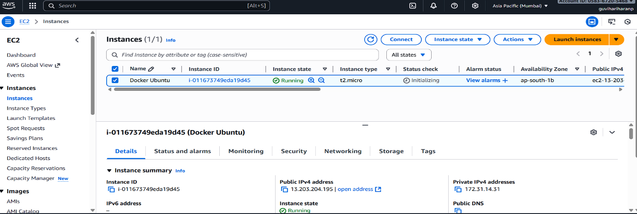

Install docker on Ec2 instance
. Sudo apt update
. Sudo apt upgrade -y
. sudo apt update
. sudo apt install docker-ce docker-ce-cli containerd.io -y
. Docker --version
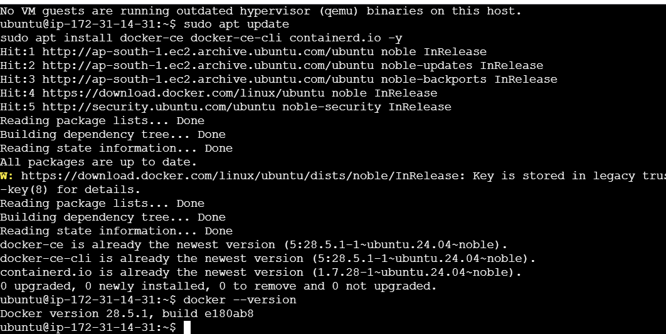
. sudo docker run hello-world
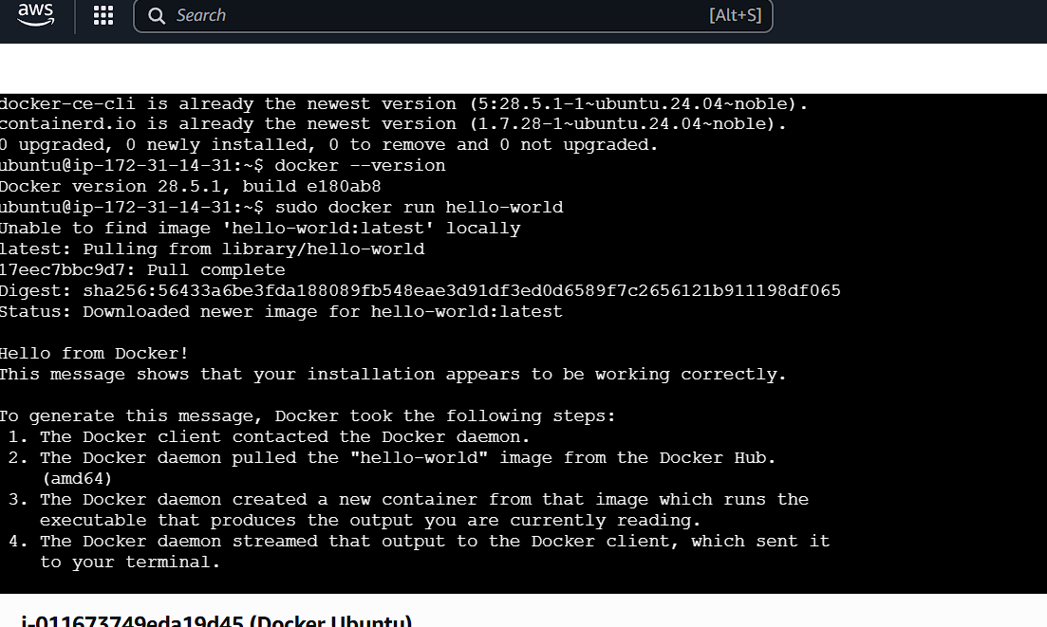

Docker Image
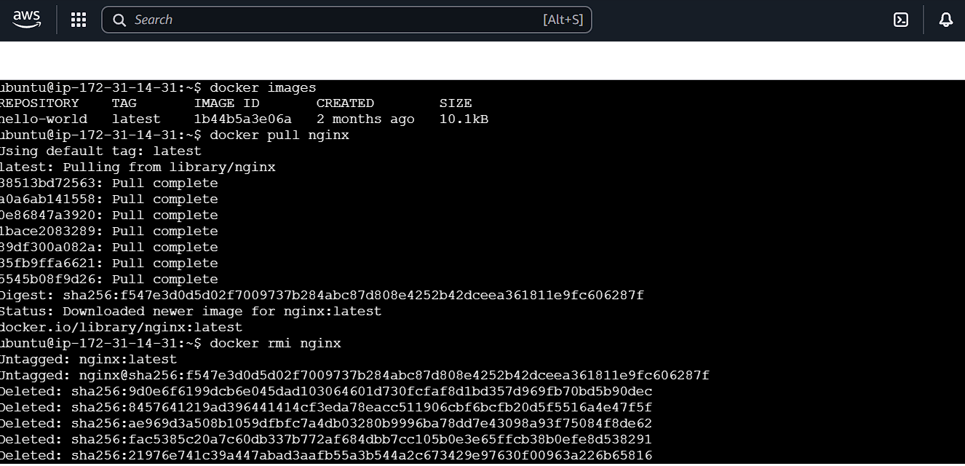

. docker pull nginx
. docker rmi nginx

Docker Containers
. docker run -d --name my-nginx -p 80:80 nginx
. docker ps
. docker ps -a
. docker stop my-nginx
. docker rm my-nginx
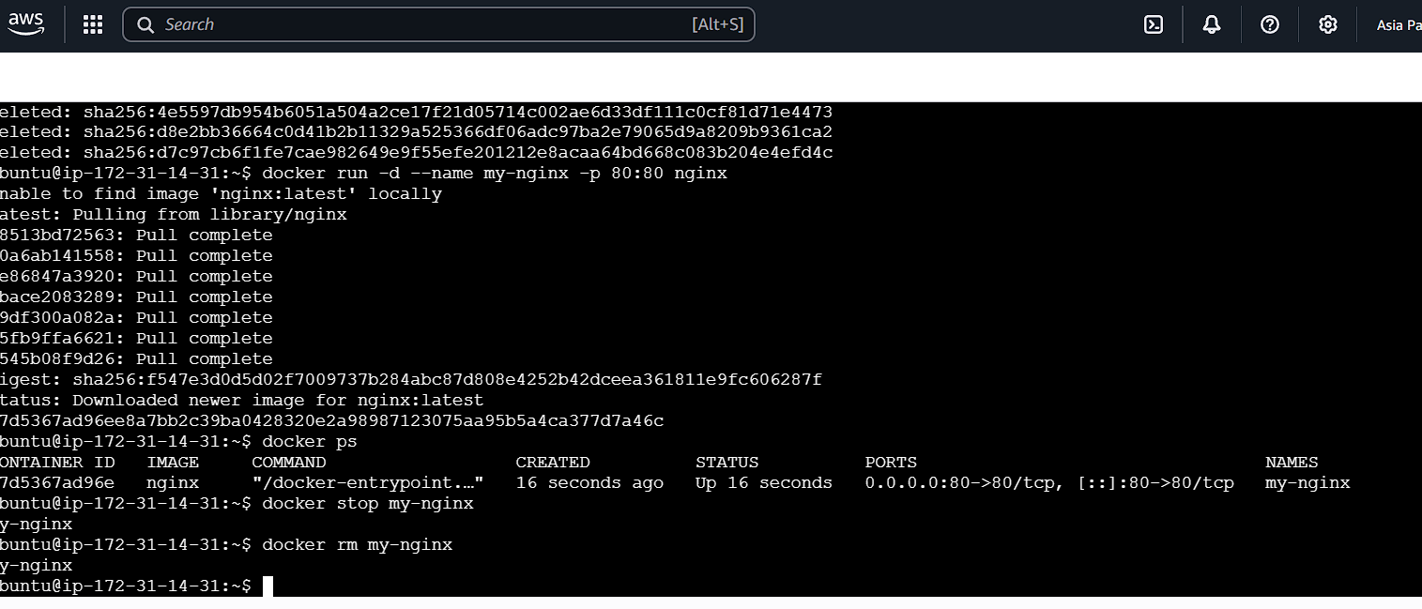
Docker Volumes
. docker volume create myvolume
. docker volume ls
. docker run -d --name nginx-vol -p 8081:80 -v myvolume:/usr/share/nginx/html nginx
. docker volume inspect myvolume
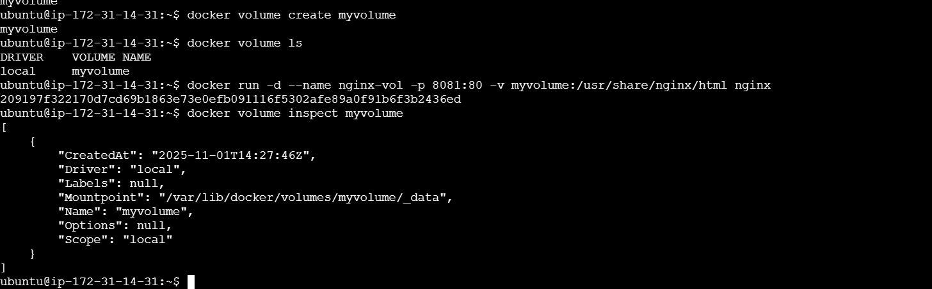
Docker Networks
. docker network ls
. docker network create mynetwork
. docker run -d --name nginx-net --network mynetwork nginx
. docker network inspect mynetwork

